➢➢ Explanation :
- We are given two numbers at memory locations D000 H and D001 H. Let these numbers be
50 H and 20 H.
- We have to subtract the byte at memory location D000 H (50 H) with the byte at memory location D000 H (20 H).
- Initially we will store the first number in the accumulator.
- Using SUB instruction subtract the two contents. Result of subtraction will be stored in the
A register.
- Store the result at memory location D002 H.
For example : | D000 H = 50 H |  | 50 H
 | D001 H = 20 H | – | 20 H
 |  |  | 30 H
➢➢ Algorithm :
Step I : Start
Step II : Get the first number in A register.
Step III : Get the second number in memory.
Step IV : Subtract the two numbers.
Step V : Store the result at memory location D002 H.
Step VI : Stop
➢➢ Flowchart : Refer flowchart 5.
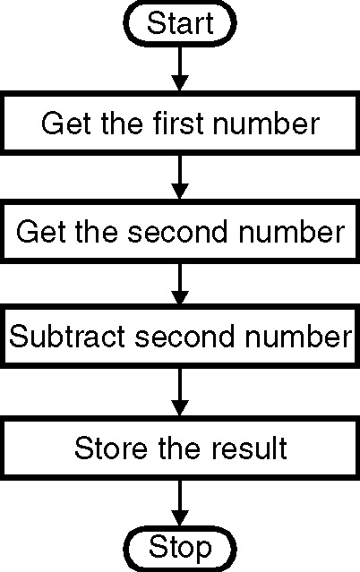
➢➢ Program :
Instruction Comment
LXI H, D000 H ; L points to the memory location
; D000 H
MOV A, M ; Get the contents of location
; D000 H into the accumulator.
INX H ; Increment HL to point to next memory
; location i.e. D001H
SUB M ; A = A – M i.e. compute the subtraction
INX H ; Increment HL to point to next memory
; location i.e. D002H
MOV M, A ; Store the result at memory location
; D002 H
HLT Flowchart 5

